Introduction

1.1 Introduction to grid computing

A scientist studying proteins logs into a computer and uses an entire network of computers to analyse data. A businessman accesses his company’s network through a PDA in order to forecast the future of a particular stock. An army official accesses and coordinates computer resources on three different military networks to formulate a better strategy. All of these scenarios have one thing in common : They rely on a concept called Grid computing.
Grid computing is a group of network computers that worked together as a virtual supercomputer to perform large task such as analysing huge sense of data or whether modelling.
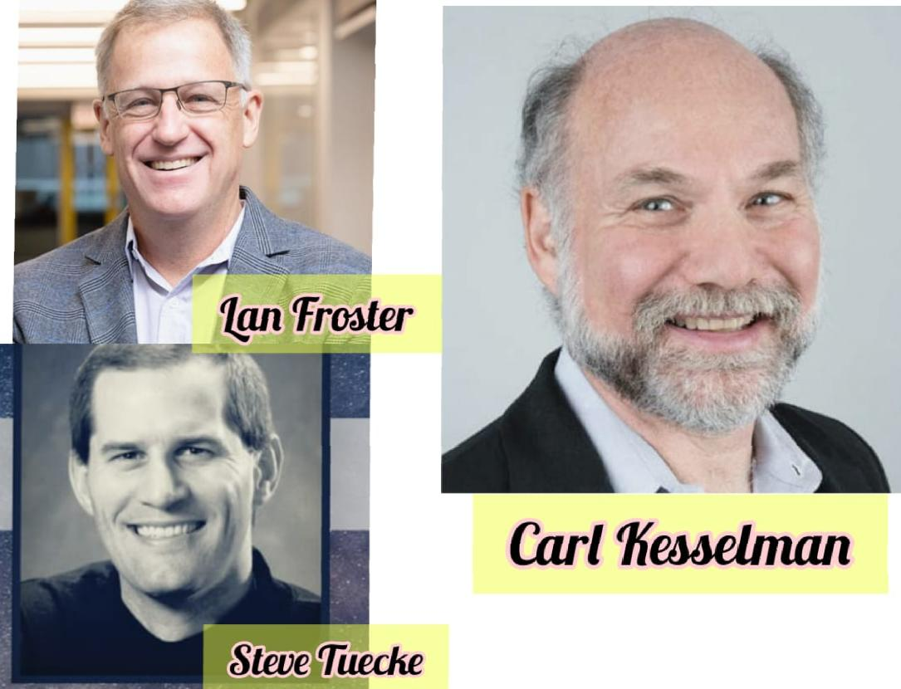
The idea of grid computing was first established in the early 1990s by Carl Kesselman, Lan Foster and Steve Tuecke.

Figure 1: Computer scientist who discovered the idea of grid computing.

What is Grid computing ❓

- Grid computing as a computer network in which each computers resources are shared with every other computer in the system.
- It is distributed architecture of large number of computers connected to solve a complex problem.
- In the grid computing model, servers or personal computers run independent task and are loosely linked by the internet or low speed network.
- It is a special kind of distributed computing .
- In distributed computing, different computers within the same network share one or more resource ( Resources like RAM ,Processor, Hard disk ).
- In the ideal grid computing system, every resource is shared, turning a computer network into a powerful supercomputer.
- Every authorised computer would have access to in normal processing power and storage capacity.
So , grid computing system uses the concept of sharing the load across multiple computers to complete a task more efficiently and quickly. Before going to much further, let's take a quick look at computer’s resources :-

Processors - The brain of the computer or the central processing unit (CPU) is the part performs any needed calculation or processing.

Memory - Temporary storage used for calculation of processing.

Storage – Long term hold space used to contain needed information or results.

Software – Program used to control the resources, or perform needed processing.

How it works ?

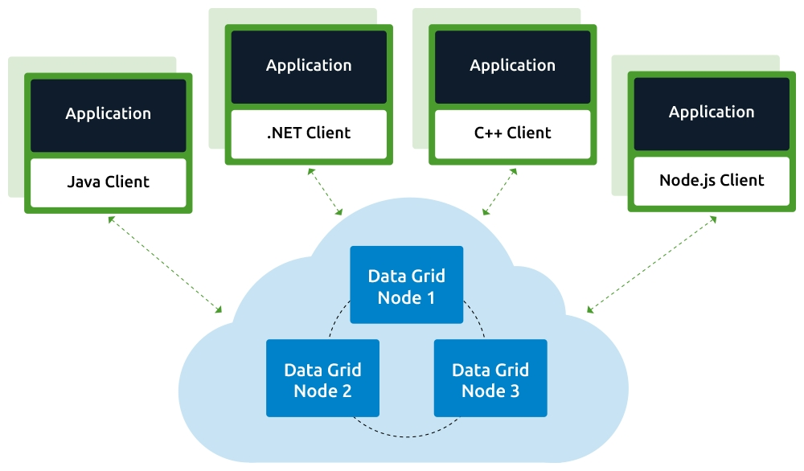
Grid computing typically run on a data grid , a set of computer that directly interact with each other to co-ordinate jobs. Grid computing works by running specialised software on every computer that participate in the data grid. The software acts as the manager of the entire system and coordinates various task across the grid. Specially, the software designs subtasks to each computer so they can work simultaneously on their respective subtask. After the completion of subtasks, the outputs are gathered and aggregated to complete a large scale task. The software leads each computer communicate over the network with the other computers so they can share information on what portion of the subtasks each computer is running, and how to consolidate and deliver outputs.

Figure 2 : How Grid Computing works ❓

The advancement of grid computing system is increasing day by day. There are many other kinds of research and advanced developments happening in the grid computing, supporting the implementation of new standards and protocols.

Components of Grid computing

Control Node : It is a group of server which administrator the whole network .

Provider (Grid Nodes) : It is a computer which contributes its resources in the network resource pool.

User : It is a computer which uses the resource on the network.
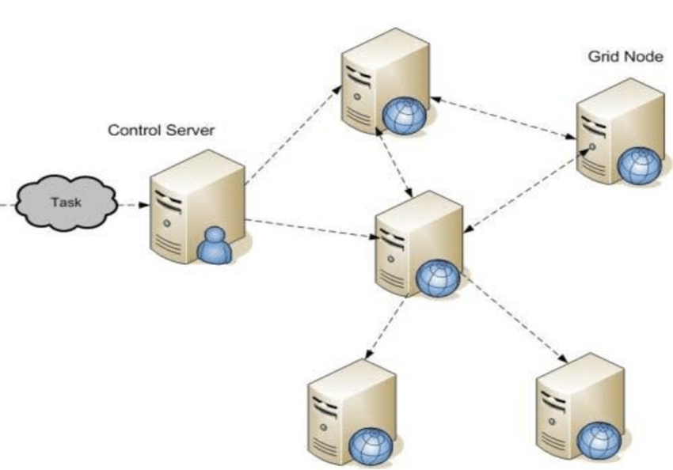

Figure 3 : Components and Working of Grid Computing.

CPU, memory and storage units are the fundamental unit of the greats computing system. Based on the requirement and need, there might be a computer of one CPU or multiple CPUs. They have a microprocessor by which day perform all the mathematical functions. Finally the processed information is sent to different memory locations. The memory of the computer is similar to the temporary electronic storage, which keeps the related data available for the microprocessor. The microprocessor has to search and extract the data from Storage components such as any hard disk or USB drivers or reliable database without any memory component. Storage is an important function in grid computing that should be open source and accessible at any time.

Grid architecture

Grid architecture refers to the way the entire procedure with which the grid has been designed. These can be described in terms of various layers that perform a common function. These layers are:
- The lowest layer refers to the layer of the network.
- Resource layer, which does above the network layer.
- The middle layer is responsible for the tools that make various elements.
- The top layer is the layer of the applications.
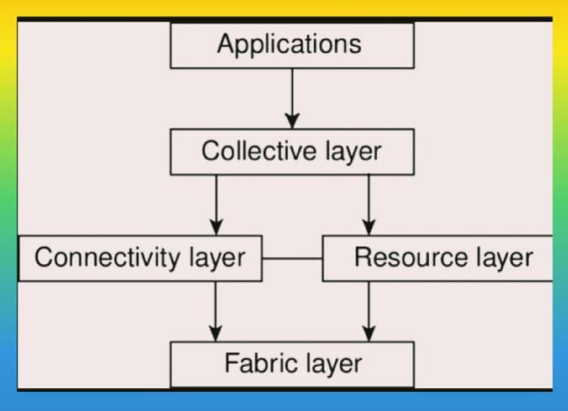

Figure 4 : Grid Architecture.

Types of Grid

4.1 Computational Grid – It acts as the resource of many computers a network to a single problem at a time. Computational grids are often more cost-effective than supercomputers of equal computing power.

Data Grid – It deals with the controlled sharing and management of distributed data of large amount.

Collaborative Grid – It solves collaborative problems.

Manuscript Grid – Sometimes called a block grid or single column grid, the manuscript grid is the simplest grid structure. It's mainly a large rectangular area taking up most of the space inside a format.

Uses :- Manuscript Grids are used in documents, ebooks, pdfs and presentations with lots of text.

4.5 Modular Grid - Modular grids are useful when volume does not provide a sole solution to the problem.
Uses :- Now a days it is used in web design.

Uses of Grid Computing

Grid computing plays a very important role when a task requires more than one expert to complete the job. After working individually on their area of expertise, the experts can collect the data, note down their findings, and gather them to take out the final results. Here are a few grid computing examples where grid computing is used:
- Movie: The film industry has been using the process of grid computing for a long time now. Grid computing not only helps in special effects in the films but also ensures faster production.

- Gaming: The gaming industry also uses grid computing techniques in applications like in-game cut scenes, multiplayer game hosting, and much more.

- Life sciences: Life sciences make use of grid computing for data calculation and analysis.

- Engineering and design: Grid computing has been very useful in engineering and designing in analysing real-time data, experimenting with new models and methods, and verifying the existing models.

- Government: Government has been using the procedures involved in grid computing for various defence and safety reasons of the country.

- Supercomputing: It is another such area where grid computing has performed exceptionally well and flourishes even more. Various fields where grid computing plays an important role are:

- Distributed Supercomputing
- High-throughput Supercomputing
- On-demand Supercomputing
- Data-intensive Supercomputing
- Collaborative Supercomputing .

Roles of Grid Computing Organizations

Based on the functional role they play, grid computing organizations have the following functions to play:

Middleware: grid computing organizations act as a middleware solution between the client and the company. Such companies prove beneficial for both parties because the client gets the work done early, and the company saves energy, resources, and money.

Commercial purposes: Grid computing organizations adopt grids concepts to be used in commercial purposes for various companies.

Guidelines for practices: The grid computing organizations involved in developing the grids’ standards also enable promoting and establishing the procedures for the same for training.

All in one solution: The organizations provide the answers to the computing solving, data, and the requirements of the network.

Advantages of Grid Computing

- Can solve larger, more complex problems in a shorter time.
- Easier to collaborate with other organizations.
- Make better use of existing hardware.
- No need to but huge servers for applications that can be split up and farmed out to smaller commodity type servers.
- Grid environments are much more modular and don’t have single points of failure. If one of the servers/desktops within the grid fail there are plenty of other resources able to pick the load.
- Jobs can be executed in parallel speeding performance

Disadvantages of Grid Computing

- Non-interactive job submission.
- Grid software and standards are still evolving.
- Learning curve to get started.
- You may need to have a fast interconnect between compute resources.
- Licensing across many servers may make it prohibitive for some applications.
- Many groups are reluctant with sharing resources even if it benefits everyone involved.

Summary and future work

Grid computing offers an efficient method of coordinating resource sharing and problem solving in or between physically dispersed virtual organizations. It offers an opportunity to access greater computing power at a fraction of current cost of technology. Grid computing provides a powerful aggregated computing facility useful for high performance scientific and business activities. Universities and research communities have already started using the grid for solving complex and difficult problems that was previously unsolvable. Grid computing will have a great impact on the education, research and business activities of the developing nations. It is high time for the academic and business communities to work together and realise this promise.
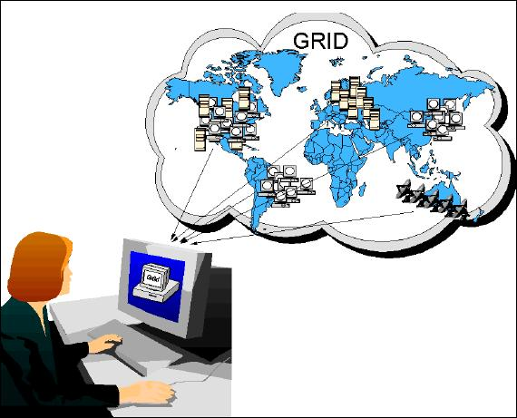
Figure 5 : A woman using the concept of grid .
The concept of grid computing is great in future it will definitely achieve progress because now a days everyone is searching for fast internet access and this is available in grid. As in grid many computer resources are working together as a virtual supercomputer. As we all know that a super computer is quite costly so in future you cannot afford such a costly super computer can work on the concept of grid computing it will definitely help him or her to complete his or her work more efficiently and quickly.
REFERENCE

- https://www.geeksforgeeks.org
- https://azure.microsoft.com
- https://hazelcast.com
- https://en.m.wikipedia.org
- https://www.techopedia.com
- https://www.redbooks.ibm.com
- https://computer.howstuffworks.com
- https://ecomputernotes.com
- https://www.javatpoint.com
- https://www.dartmouth.edu
- https://www.pdffiles.in
- https://www.toolbox.com
- https://www.quora.com

From YouTube :-
- https://youtube.com/channel/UCKS34cSMNaXaySe2xgXH-3A
- https://youtube.com/channel/UC-oKX6xAZGW8qTeGOoIe9-A
- https://youtube.com/c/PywixClasses
- https://youtube.com/channel/UCQHTnpCq1qHaCxf1-5MOePw

